**PROBLEM IDENTIFICATION**

In order to realise the goal of demographic divide, every citizen of the country needs to be educated for job, be it a scientist, a doctor, engineer or whatever to meet not only the needs of our society but also the other societies elsewhere in the world. Every student aspires to become a great person and self-reliant, but their passion and linking are diverse. In order to cater to the aspiration of the students and facilitate them to aim it high, they are required to be informed about the number and types of jobs this country has in the future years, as also the number of business persons , entrepreneurs , workforce in all areas of employment. A national database of actual requirement of workforce, category-wise by both government and industry, the type of educational or skill qualification required, nature of job, eligibility criteria, salary and perks, career development/progression in every field/ sector of employment is urgently required.

As each individual nurture different desires to become in their life, there is a need for career dendrogram, so that one can put forth a concerted efforts to become the best in his vocation and excel in life rather than make umpteen number of mistakes of wrong selection of course of education or career and repent later and go on trying different things losing his precious time/life.

**PROPOSED PROTOTYPE**

The major component in the project is national database which stores the whole information of the available jobs in India. The project is web based. The project is developed using HTML, CSS and PHP.

**Technology Stack**

|  |
| --- |
| CSS |
| HTML |
| JavaScript |
| Web Page |
| Operating system |

**Server side Client side**

|  |
| --- |
| Web Frame |
| PHP |
| MySQL |
| Web Server |
| Operating system |
| Server |

**Use Case Diagram**

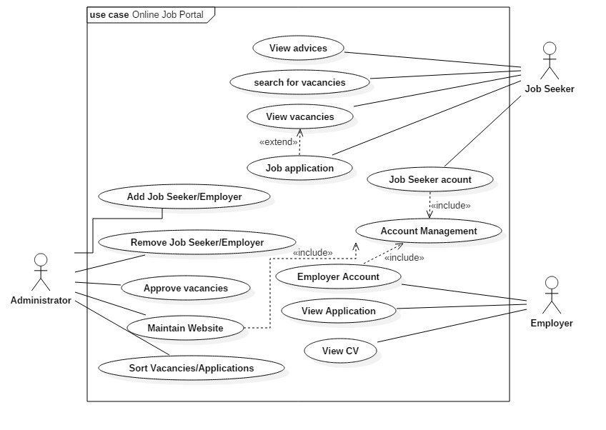

**Showstopper**

The fast growing technologies are making everything change just at a click. Organisations are willing to have the same quick and fast process to hire resources with ease and more effectively to get right candidates and for this purpose, they take help of online job portal. Our website is more interactive than the other websites. It has eye catching interface and easy to access. Moreover this site provides detailed information about the job.

Why Us?

As the trend of online technology is emerging and most of the things are now available on the web, we here provide that information which is kept hidden on the other site. Ranging from Experience required